Hello there developers,

As a new amateur to the Developer Community, I had a few hurdles that I had to cross in order to find a way and install the IRIS for Community Edition.

The Developer Community has been very helpful in guiding me thought this process, and which has made me write this post today.

I believe that this will be helpful for any armature on the Developer Community trying to get hands on experience with IRIS.

**Steps to be followed.**

**Step 1**

Become a member of the Developer Community.

For this you either need to be invited to the Developer Community by a friend of yours or you need to be referred to it via the Global Masters which also needs to be done by a friend.

OR

You can log on to the following link and become a member of the Developer community.

<https://login.intersystems.com/login/SSO.UI.Register.cls?referrer=https%3A//community.intersystems.com/>

Image attached below.

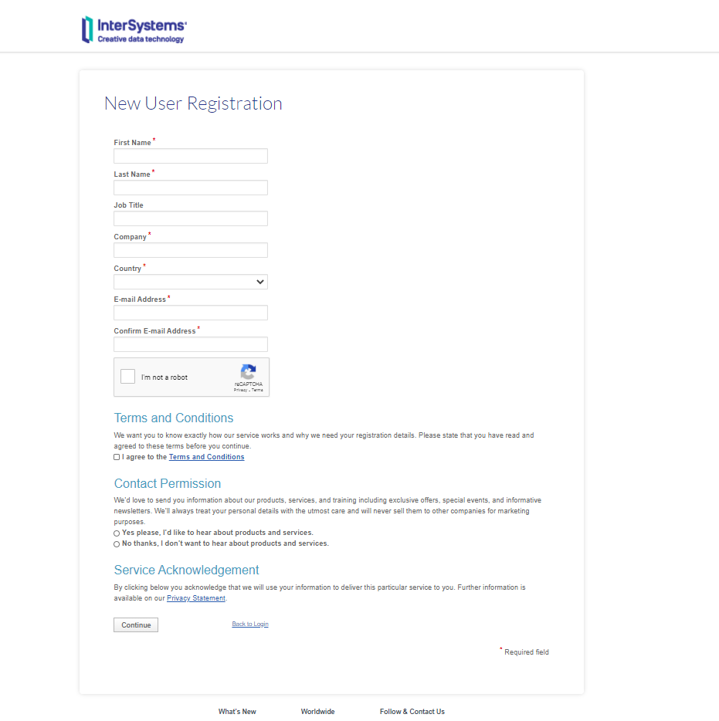

**Step 2**

Once you are a registered member of the DC you need to download IRIS of your choice or you could also use IRIS online. The link for both will be given below.

Link to Download IRIS:

<https://download.intersystems.com/download/login.csp>

Link to try IRIS online:

<https://www.intersystems.com/try-intersystems-iris-for-free>

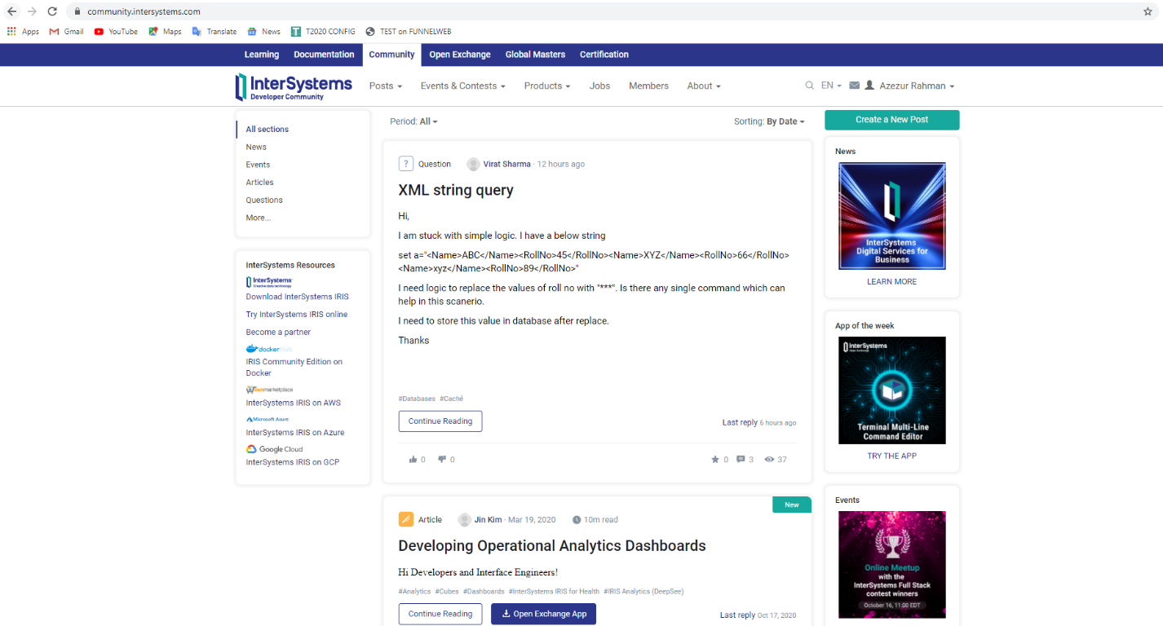

If you are to download the IRIS then you got to choose from either one of these 2 of your choice.

NOTE: You are eligible to do this only if you are a registered use.

|  |
| --- |
| Shows the registered users name. |

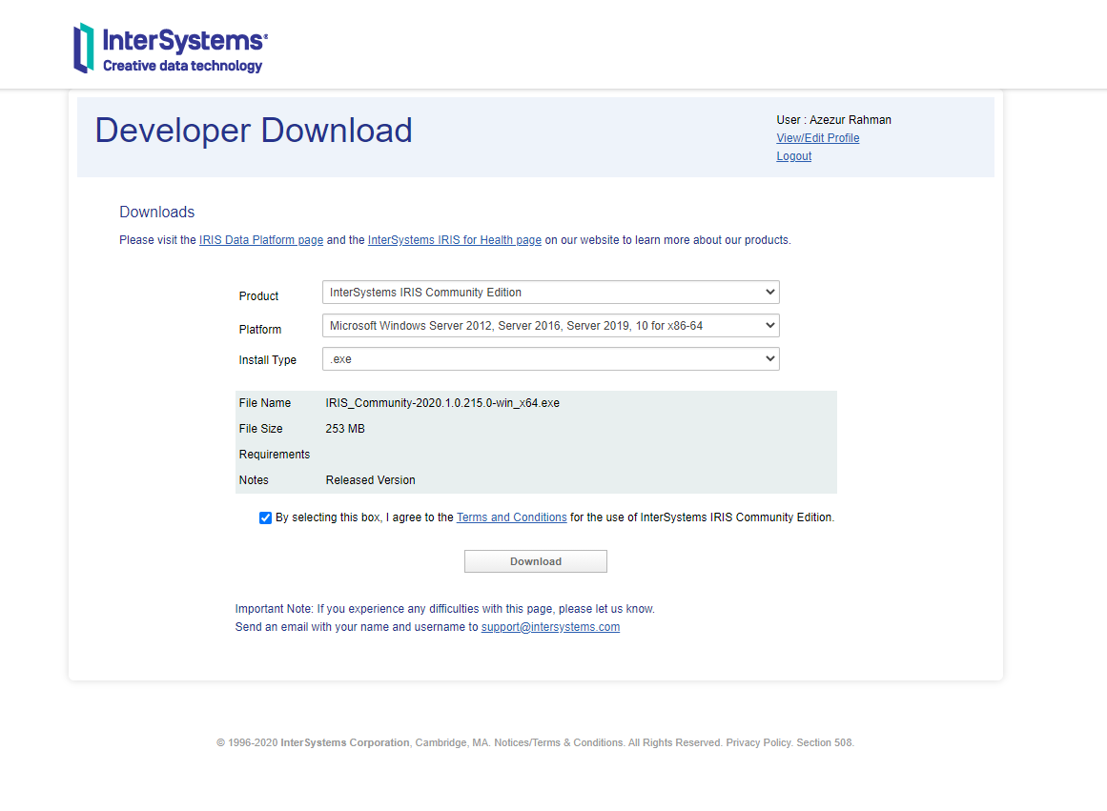

1. InterSystems IRIS for Health Community Edition.
2. InterSystems  IRIS Community Edition

There on all you must do is read and provide appropriate details and appropriate storage location for the application to be downloaded and installed.

**Step 3**

**User License Agreement Acceptance.**

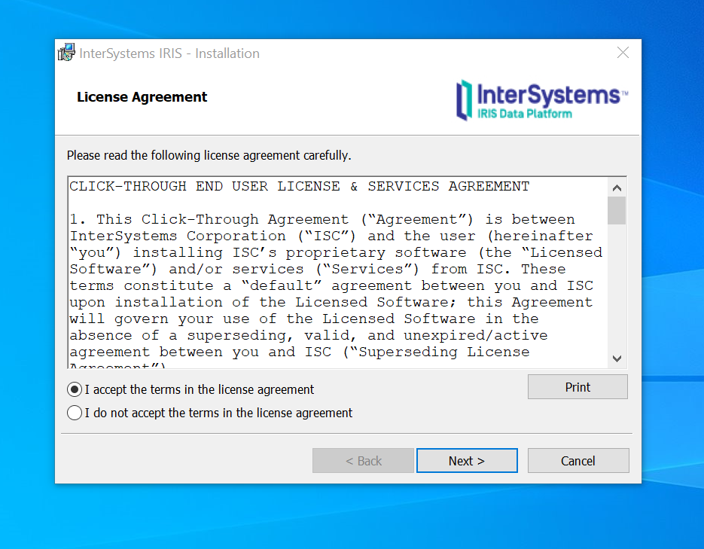

**Step 4**

**Appropriate naming**

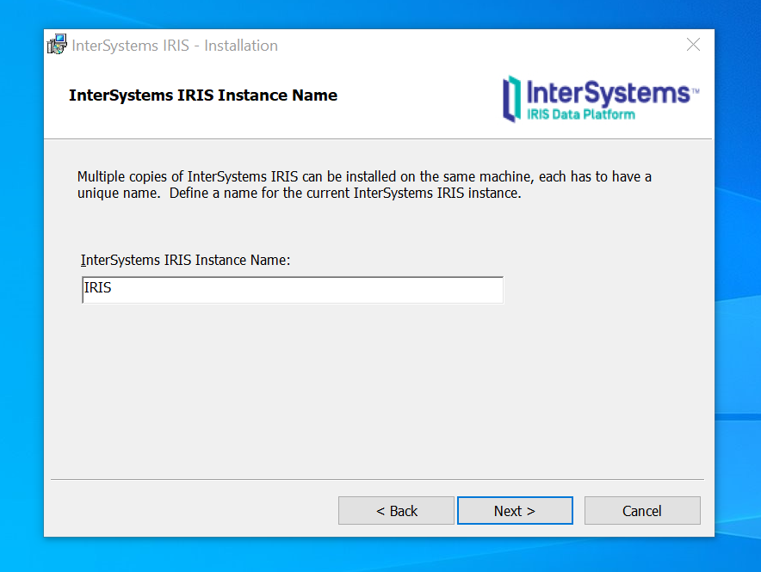

**Choosing the appropriate Uni code.**

**For any new application you'll want to select Unicode. 8-bit would be used for legacy applications that were designed for 8-bit character sets.**

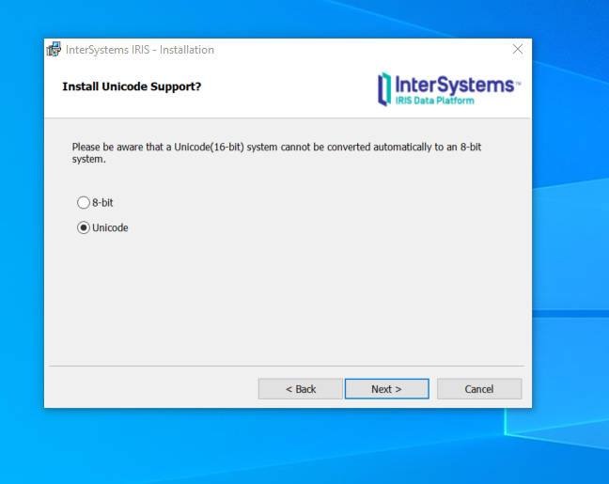

**Step 5**

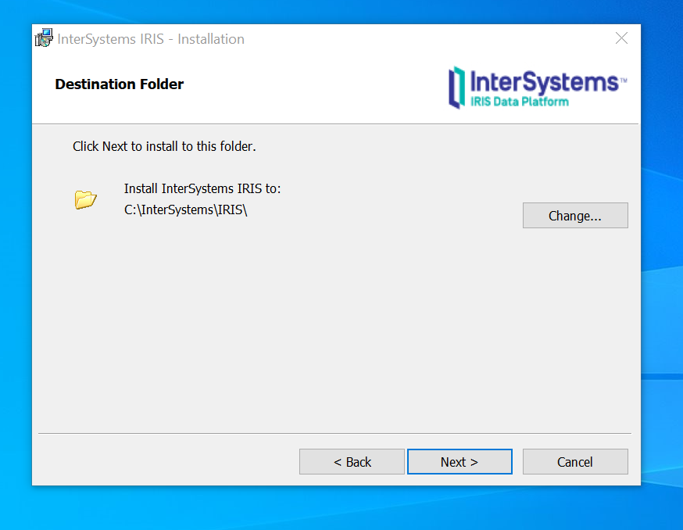

**Step 6**

**By choosing Development you will get the full package installed that is needed for your use.**

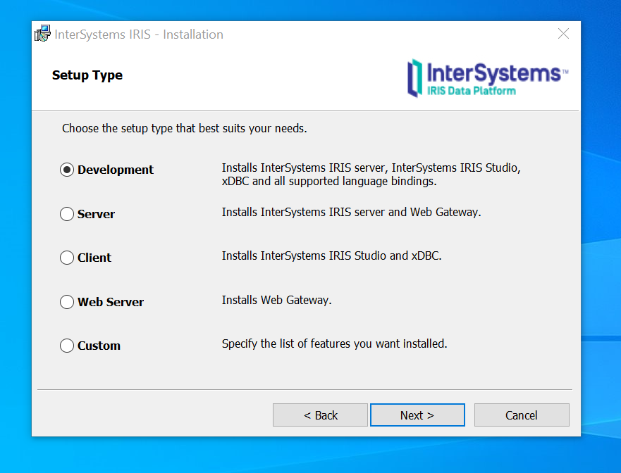

**Step 7**

**Choose appropriate Security Levels depending on the scale of what you are to do.**

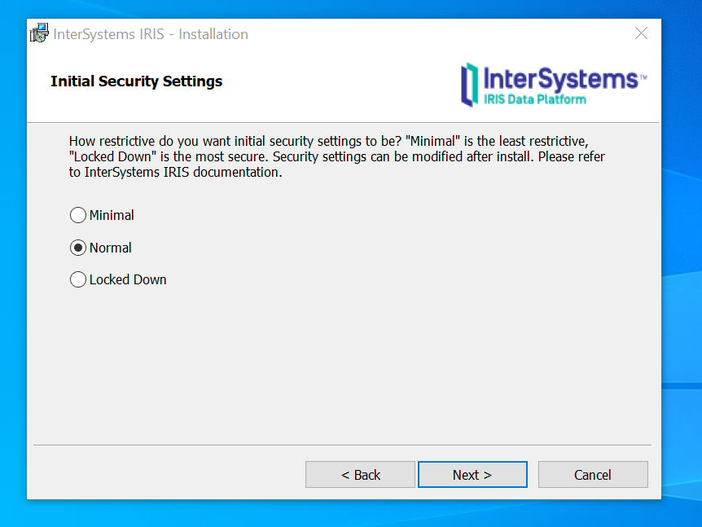

**Step 8**

**If you are an InterSystems Employee and do not want to get your system clashed better use default System account.**

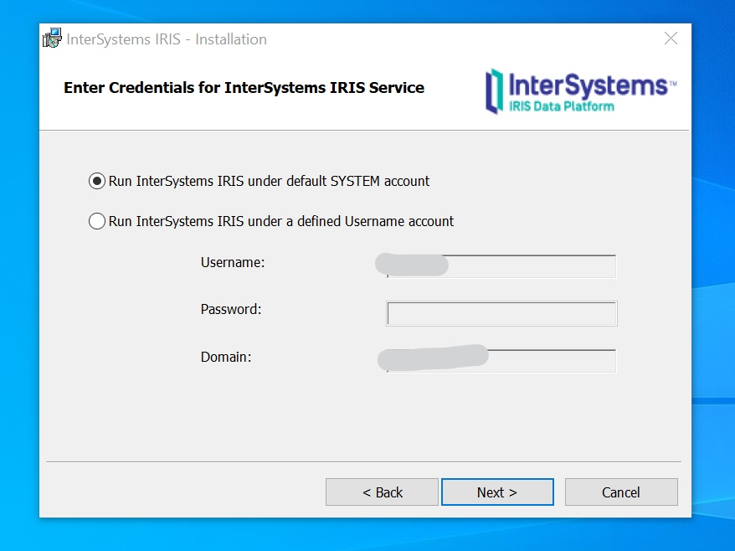

**Step 9**

**Give it a strong password to secure it.**

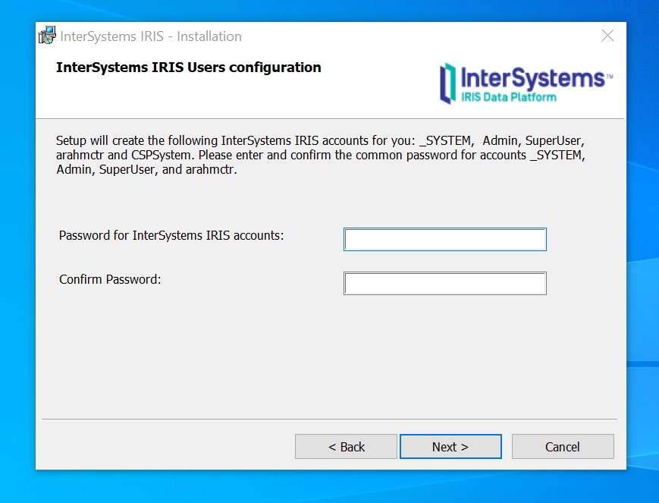

**Step 10**

**Now you will be required to enter another password for the CSPSystem.**

**During the installation process a stripped-down version of the apache web server will be installed too (to serve the management portal and for test purposes). This is the CSP-System (CSP means CacheServerPages). Enter a password, you will need it rarely or almost never.**

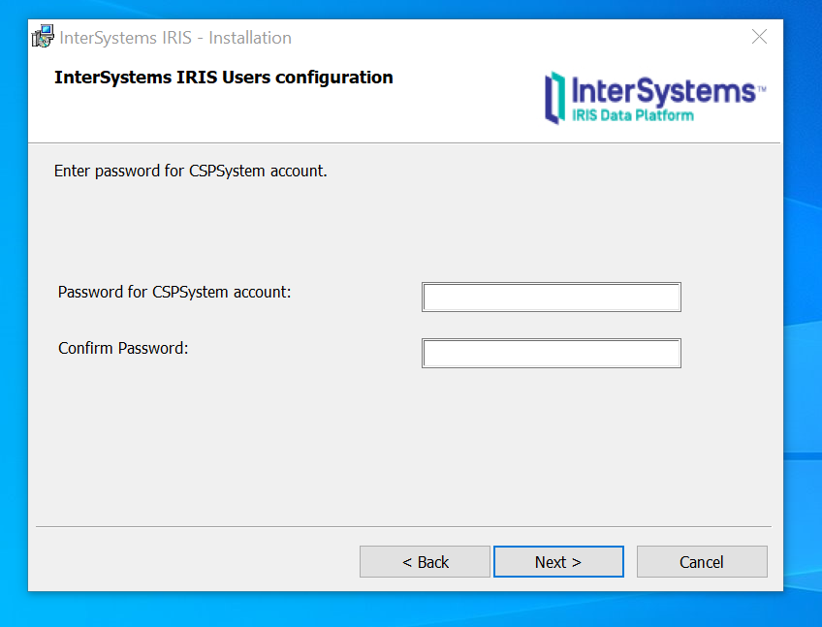

**Step 11**

**Carry on with the Installation**

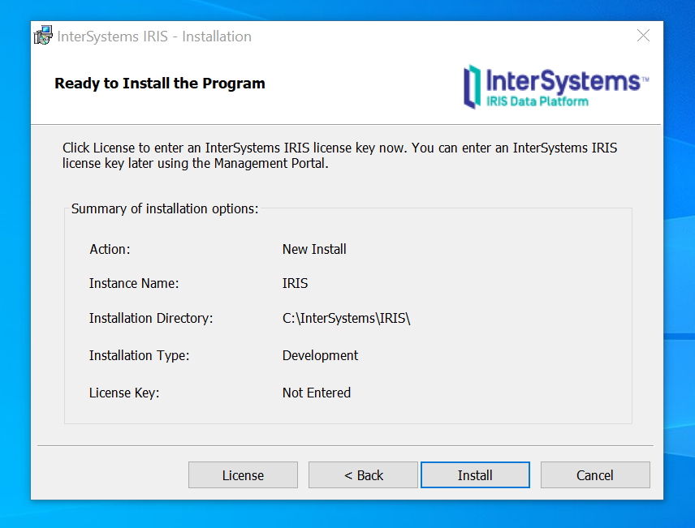

**Step 12**

**Complete Installation and Enjoy IRIS development**

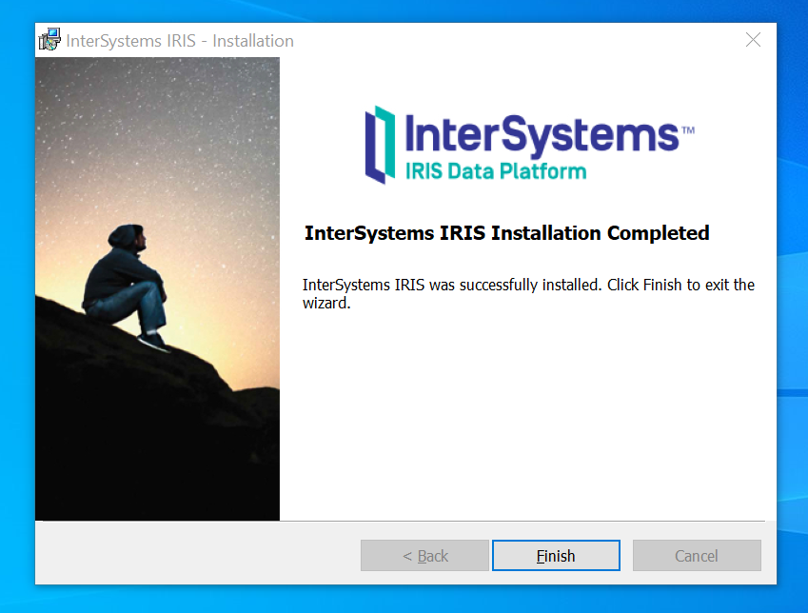

55

101232

Replies